contacts
West Essex & East Herts Guild of
Spinners, Weavers & Dyers

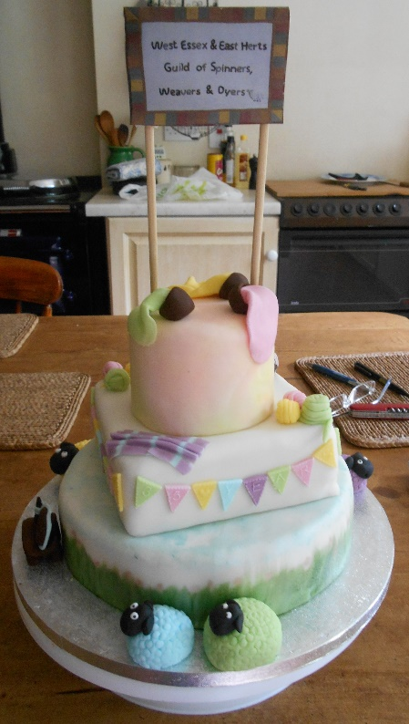
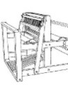

Threads

September 2015

Chair | Carolyn Green
Vice-Chair | Lesley Ottewell
Secretary | Mary Hicks
Treasurer | Cate Barnett
Publicity Officer | Asela Ali
Programme Secretary | Sue Prior
Committee Member | Chris Lane
Guild Website
www.westessexeasthertswsd.weebly.com
Members of the Committee 2014/15
Guild Programme 2015
Saturday 12 September 10.00 a.m. - 4.00 p.m.  Widford Hall | Knitting Workshop with Juliet Bernard  Continental knitting, mosaic techniques and Q&A session
Thursday 8 October  7.00-9.00 p.m.  Harlow Museum | Annual General Meeting and Competition:  “50gms Odd Ball” – Make anything from 1 ball in your stash
Thursday 12 November  7.00-9.00 p.m.  Harlow Museum | Needlework in Art – Talk by Clare Ford-Wille
Thursday 10 December  7.00-9.00 p.m.  Harlow Museum | Christmas Social

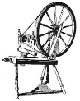
We look forward to seeing you soon
Indigo and Silk
by Carolyn Green

As part of our annual project this year, Guild members joined together to dye hand-woven shibori scarves at Pat Holder’s home in July. Some members had a go at dyeing before the day and there were a range of results. A few of us found, when Procion dyeing our scarves, that what we wanted and what we got were two different things. My scarlet dye bath produced a fuchsia end product on the silk; not at all the colour I was hoping for, although the cotton pull-up threads were spot on. Those who chose russet ended up with just the scarlet I wanted, but with russet cotton threads.

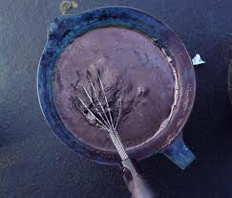
We all have our favourite recipes, this probably applies to dyeing, too. I’m not an expert and spent my early experience turning up at dyeing days with wet yarns, dropping them into dye baths and going home with whatever resulted. This particularly applied to indigo until I sent off for a kit from Fibre Crafts (George Weil) and made my first attempt of dyeing almost from square one (that being growing your own!). This was the recipe I used and to my relief, it worked, despite fears that the Thiox (reducing agent, deoxidiser) has degraded and wasn’t going to clear the indigo solution.

For those who want to try their hands in the privacy of their own homes, this is the method I followed. I used natural indigo powder – synthetic indigo has a higher percentage of indigo, weight for weight, so less can be used. The instructions are for about 1kg of fibre/ fabric/ yarn.

Stock Solution:
- Mix 8g powdered indigo with 5gm thiourea dioxide in a jar, work into a paste with half a cup of warm water. Cover and leave for 15 minutes.
- Dissolve 50g sodium bicarbonate (soda ash) in 250mls water, stirring until dissolved. Add this to the indigo mixture very carefully and stir well. Cover and keep at around 37 degrees Centigrade and leave to stand until the solution clears. This can take between 30-60 minutes.
- When it seems ready the ‘bloom’ at the top of the liquid should be greenish. Dip a stirring rod into the liquid which should be blue when withdrawn. If there are white specks, add more soda ash; if there are blue specks, add a little more thiourea dioxide.

Dye bath:
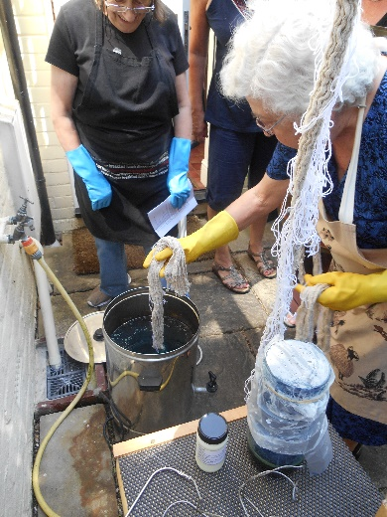
- Fill the bath with about 2/3 warm water at a maximum 50 degrees Centigrade. Add half a teaspoon of thiourea dioxide and stir. Cover to allow deoxygenating for about 20 minutes.
- Very carefully pour about half the stock solution into the dye bath, avoiding any disturbance of the top layer. Stir very gently to avoid introducing oxygen, cover and leave for 20-30 minutes.
Dyeing:
- Wear rubber gloves and lower wetted fibre/fabric gently into the dye bath. Immersing both hands gently squeeze the fabric under the surface without agitating the bath, then leave for 5 – 10 minutes.
- Remove the item with care, squeezing out excess liquid just above the surface as it emerges to avoid oxidised drips back into the bath.
- Hang the dyed item to drip dry and watch it magically turn from a green-yellow to blue.
- Repeat the process until the desired depth of colour is achieved. More stock solution may be added as more items are dyed.
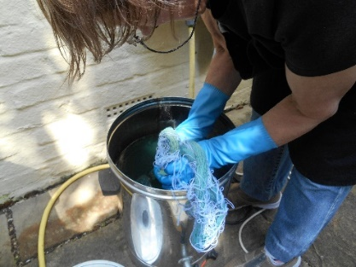
- If the dye bath urns blue, add more thiourea dioxide, 1 teaspoon at a time leaving it about 15-20 minutes after each addition.
- The dye bath will keep for 2- 6weeks if kept covered in a warm place.

Thiourea dioxide can be bought from –
- George Weil as ‘Spectralite’
- PM Woolcraft as ‘Thiox’
- Dr Backmann as ‘Colour Run Remover powder’

It is a toxic, inflammable chemical. Avoid inhaling and keep it away from naked flames. Keep in a dark place away from children and pets. Always wear rubber gloves during this process.

Coldharbour Mill, Devon

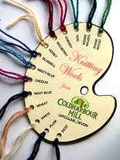
As part of a 1000 mile road trip across the south of England, I recently visited Coldharbour Mill in South Devon. It is where John Arbon trained and is now a museum that still produces yarns and local Devon tartan. Coldharbour Mill has been spinning worsted and woollen for 200 years. Built by Thomas Fox in 1799, the mill was an important centre for employment and played an integral part in establishing Fox Brothers & Co. as renowned global exporters of high quality worsted yarn and cloth.
When closure came in 1981, a result of a national recession and the popularity of man-made fibres, the mill was already a museum piece - a time capsule of techniques and rare machinery dating from the reign of Queen Victoria.
In 1982 the Coldharbour Mill Trust bought and reopened the factory as a textile museum, so preserving a unique piece of social and industrial history.
As such it has been visited by many thousands of school children as part of their National Curriculum Keystage studies in line with the Trust`s founding statement that it should "....provide for the advancement of public education (in particular in the woollen industry) by the provision of a public working museum.....".
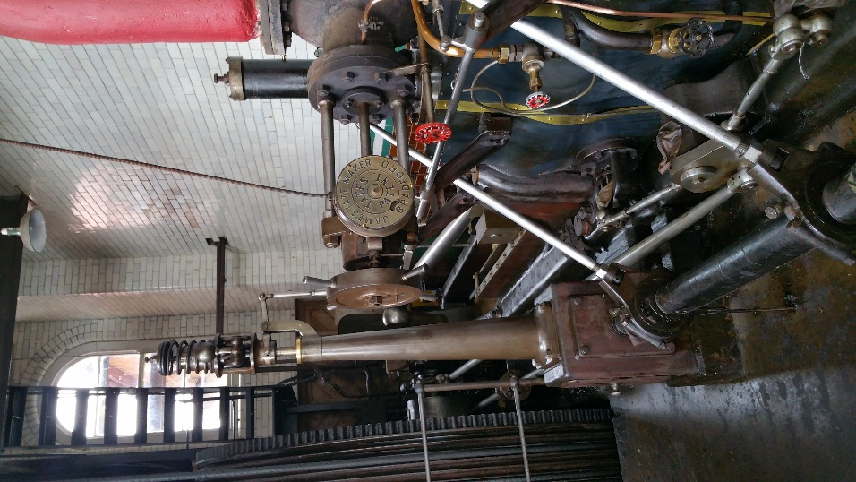
Whilst I was spoiled by the lovely ladies of the Friends of the mill, my partner was taken to look at the mill’s impressive array of power sources including a recently restored 1821 High Breast Shot Water Wheel, the largest in the South West, an 1867 Kittoe & Brotherhood Beam Engine, a rare 1910 Pollit & Wigzell 300hp Steam Engine and a Lancashire Boiler, which they 'Steam Up' on special event days.
On the first floor of the Mill, there is an exhibition celebrating the manufacture of puttees - one of the Fox firm's iconic products -and the Fox Gallery houses a permanent 'Home Front' exhibition with displays and memorabilia relating to the war (WWII) years.
The mill shop sells many unique products, including a range of knitting wools and fabrics manufactured exclusively by the mill.
By Asela Ali

What Fun!
By Sue Pulham

Last Friday a group of us met at Hilary’s house and had a real fun dyeing day. We were lucky with the weather and were outside in her lovely garden for most of the day which was just as well considering the pungent aromas we produced!

Hilary treated us to an indigo bath which apparently had been resurrected after a 4 year ‘rest’ and a madder bath and a weld bath. So with the blue, red and yellow we had a wonderful choice. The indigo is like magic – I still can’t believe the wonder of seeing the yarn change colour as the oxygen hits it. It makes me want to dye everything blue!!

We were like a coven of witches with our cauldrons – the mordant vats on the cooker inside and the dyes outside. Michele instructed us on the wonders of spiral tie-dyeing so we all went home with pieces of tie-dyed sheet all vowing to make them into something useful!

The more I experience the magic of natural dyeing, the more I get hooked – I just need to keep up with the spinning so that I have something to dye!

Thank you Hilary for a wonderful day.

Notes on Herdwick sheep

by Mary Jackson

Vikings brought this hardy breed to the Lake District, and Beatrix Potter was instrumental in saving them. There are about fifty thousand, all within fourteen miles of Coniston. Able to survive under snow by eating their own wool, defying persistent rain on mountains, living on forage, and being hefted to their own area, they were unable to counter foot and mouth disease, a quarter being lost.

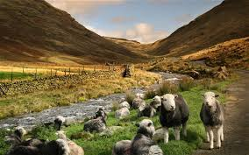

The grey ewes bear one black lamb, which after the first shearing turns grey. The tough wool, once used for carpets, fell in value to a penny a fleece, at which point the National Trust took over, and now buys and markets it, often as fireproofed loft insulation. Made into garments the bristles form a second layer which can protect from a blizzard.

It is not easy to dye. However, if you do manage to make a jumper of it and then become buried under snow, you can always eat it.

Artist’s Textiles
Last year I went to the Artists’ Textiles Exhibition at the Fashion and Textile Museum. So I should not have been surprised, when I recently went to other art exhibitions to find that famous artists were not above designing textiles for printing or weaving.

At a recent show of Barbara Hepworth’s sculpture at Tate Britain, was a wall hanging called ‘Pillar’ woven by Edinburgh Weavers, a company which is still at the forefront of quality furnishing manufacture. Ben Nicholson (Hepworth’s husband) and Paul Nash also designed screen prints for them.
a) 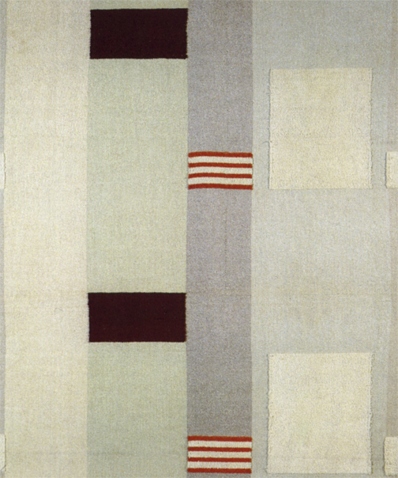 b) 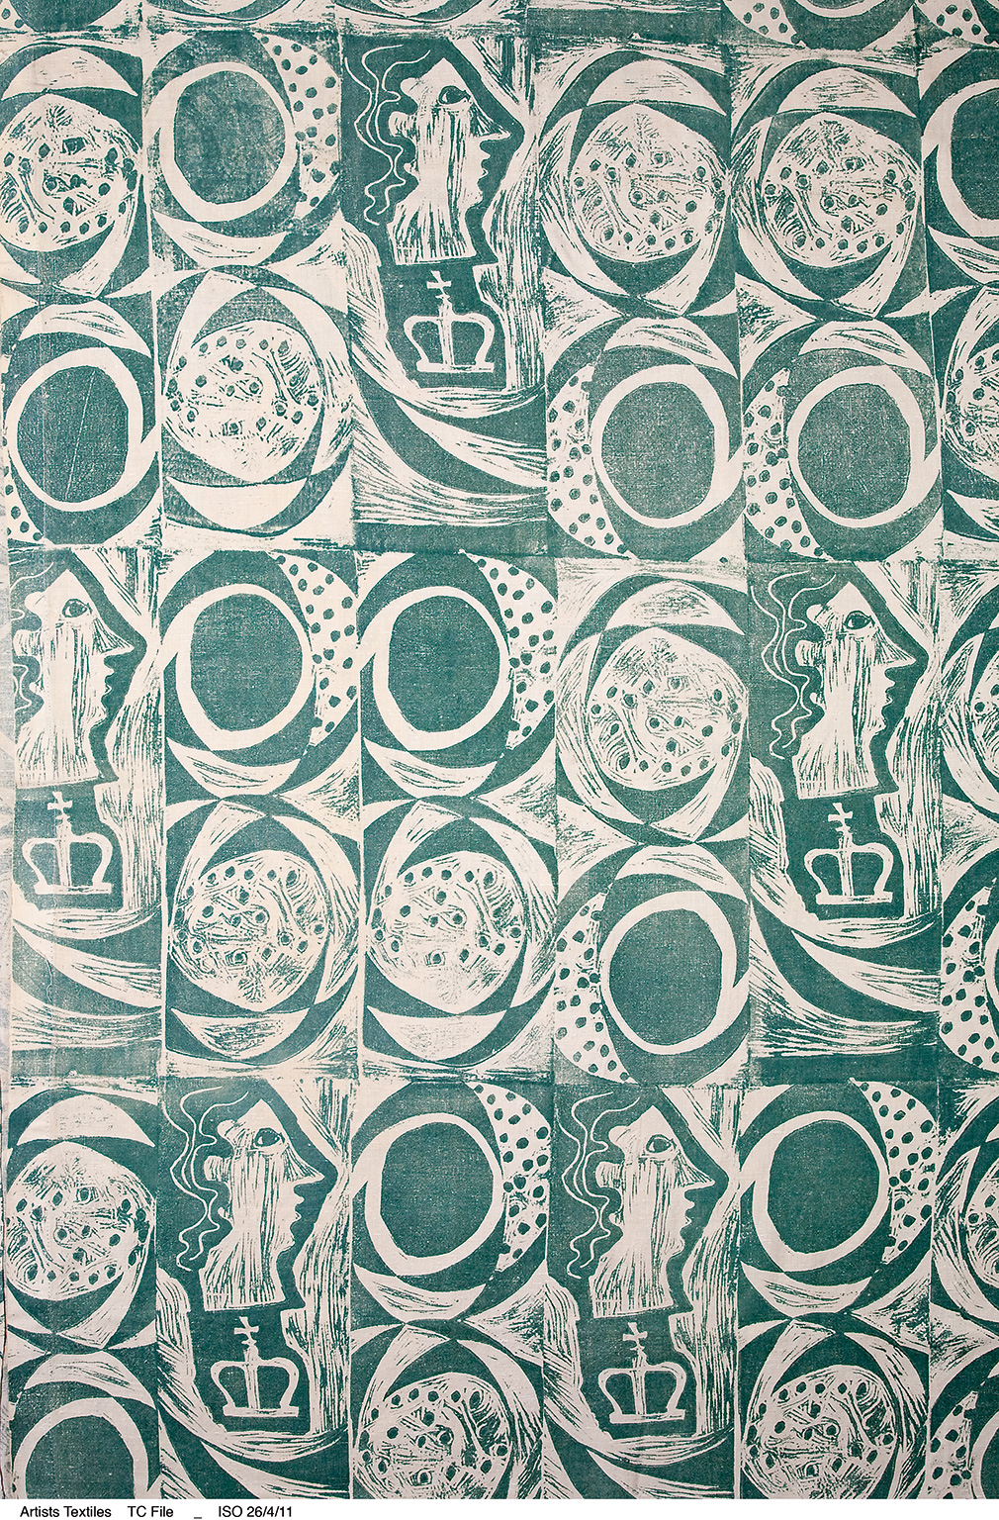 c) 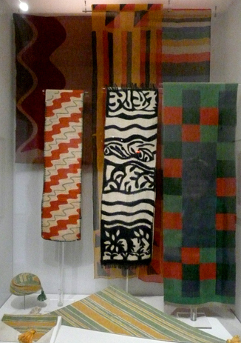

An exhibition of Sonia Delaunay’s work has just finished at Tate Modern. She too ventured into producing furnishing textiles in the 1920s and sold them at Casa Sonia in Paris, later renamed as Maison Delaunay.

If you have been watching the recent drama on the Bloomsbury Set, you will have seen how Vanessa Bell and Duncan Grant decorated their farmhouse at Charleston in Sussex. They also designed textiles which were produced by Omega Workshops, a small company set up by them to promote traditional craftsmanship in the mould of William Morris.
d) 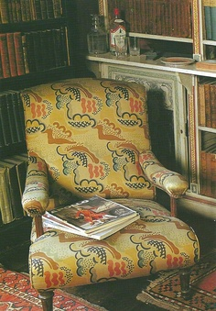
e) 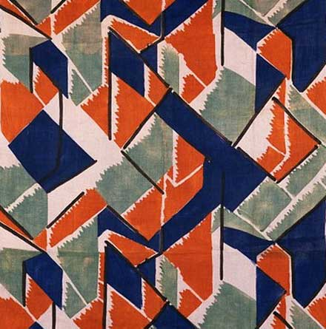
Key
- Barbara Hepworth
- Ben Nicholson
- Sonia Delaunay
- Duncan Grant
- Vanessa Bell

By Lesley Ottewell

Lesley Ottewell

Fidofur
by Hilary Hedderick

When I first joined the guild and went to Audley End with Carolyn, we met Sandra from the Dog Agility display. The dogs were beautifully groomed and Carolyn asked her what she did with their fur. It was thrown away, so Carolyn said that if Sandra collected the fur for next time we saw her, she would spin it and knit a scarf.

In October there she was with three bags of two German Shepherds and a Silver Standard Poodle for each of us. Sure enough, at the next meeting, Carolyn had made a beautiful lacy scarf for Sandra; she was delighted.
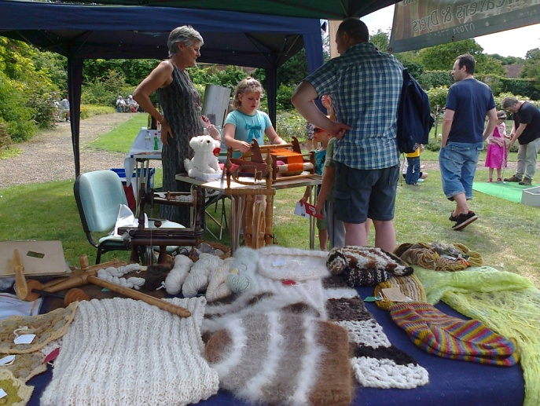
During the year Carolyn made a lovely hat with the German Shepherd fur and I was so taken with it I thought I might have a try at making one. This was the start of spinning dog fur. My youngest daughter, Fiona, had a friend with four Persian Cats and had been collecting fur for about thirty years. Fiona happened to mention one day that her mother did spinning and so I soon got a huge amount of cat fur to spin. I took a long time but I made a scarf from the fur.

After that I was asked by people I met at demonstrations if I would spin and sometimes knit their dog or cat fur for them. So far I have had about thirty requests. The name ‘Fidofur’ I thought was appropriate as I was called ‘Fido’ at school by my two best friends who were both much taller than me and I had to run to catch them up! Also, the association of ‘Fido’ with dogs, so what else could I call myself?

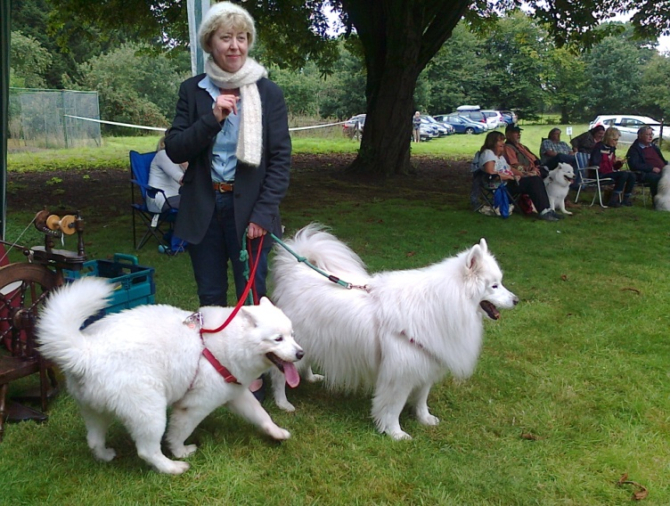
Visiting Lectures – Connie Flynn
Connie Flynn brought her collection of slides to illustrate her talk. She had taken the unusual step of enrolling for a course in Contemporary Textiles at the University of the Highlands and Islands in 2008. Shetland College was a boat journey of 200 miles from Aberdeen, which was part of a twenty six hour journey from home.
Her choice of studying in Shetland was due its location and rich textile history with inspiration from the natural environment, fascinating tales, local dialect to the exciting and challenging changeable weather.
For her BA Hons, she would be studying: weaving, knitting, surface effects, sculpture and research. Connie showed us examples of textiles in the Shetlands Museum. The traditional lace shawl was much in evidence. Because the yarn was so fine, the women rolled it in flour to make it more visible.
Traditionally, Shetland women used a leather sheath in conjunction with the knitting needles. These enabled them to walk and work at the same time. They were renowned for their speed. Indeed, a Shetland woman, Hazel Tindal, can knit 202 stitches in three minutes and holds the record as the fastest knitter.
Connie’s final presentation was entitled ‘Weathered and Worn’. There were four sections:
Decorated Darning, with its collection of jumpers,
Familiar Felting
Significant Stitching with a selection of patterns
Reviving Old Textiles
The main thrust of her work was recycling and sustainability. She combined techniques and textiles to create new images such as darning to create pattern. A research visit to Norway highlighted the textile links, which Shetland still shares with the Nordic countries. This common heritage is reflected in the knitting pieces inspired by her research. These were worked in a striking colour palette of red, black and white. Small samples of knitting in traditional patterns were felted onto a background of felt, deconstructed and embellished with hand and machine stitching.
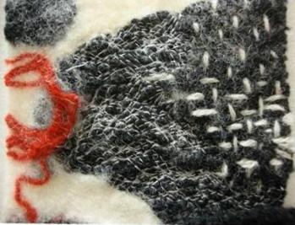
Worn Cloth was a piece of almost transparent white nuno felt is stretched over a canvas to suggest the fineness and fragility of cloth that has been well worn and constantly washed and repaired. Darning and stitching in a contrasting yarn helps to suggest age, long usage and the value cloth would have had in the past when it had to be laboriously handwoven.

Connie talked about her Claes Line Gallery (Clothes line). This was a project, which employed a domestic knitting machine to create a knitted clothes line. She fitted knitted shapes on to a background of felt.
She also mentioned ‘Pod in the Bod’, which were 3D shapes like birds’ nests. 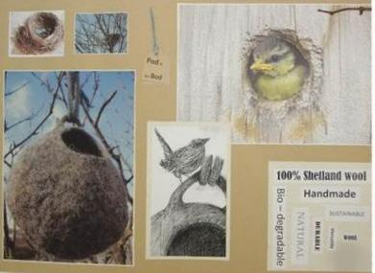
In 2009, Connie returned for a further year. Her theme was ‘Old Wives Tales’: Working the Cloth for Working Clothes, which was inspired by Shetland’s textile history and was a homage to the women who, “knit their souls into woollen masterpieces.” She took the apron as the symbolic article of clothing upon which to illustrate these ideas. This enabled her to link with history and tradition as the apron has been worn for hundreds of years in both a domestic and working environment.
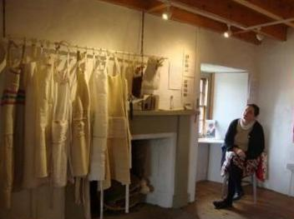
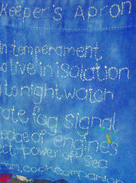
Each one of the series of aprons, which she designed and made, utilised a different textile technique. On some, as a play upon the word,”pinny,” she has used pins to replicate Shetland knitting patterns. This fascination with the use of language and dialect is alluded to in a jar of cut out words from an old edition of Great Expectations, into which are pasted old knitting designs. This evokes the practice of the passing down of treasured family knitting patterns to future generations.
She made knitting sheaths from bird feathers and covered leather. There was a coil basket as well as woven fabric for an apron. Connie has continued her association with Shetland by returning to act as Artist in Residence in such places as the Sumburgh Lighthouse. Shetland provides so much inspiration, that it appears that she cannot keep away.

By Lesley Ottewell

A day at the fair
by Chris Lane

My first solo demonstration was a slightly daunting prospect especially when I realised how much I had previously relied on other Guild members to remember to bring, well, nearly everything!!! And how much of it there was to remember; the table cloth; the Guild programmes; some knitted/crocheted hand spun and hand dyed items; hand spun skeins, etc., etc. and that was without my own needs, chair, wheel, drop spindle, fleece, scissors (nearly forgot them), lunch (I did forget that) and a rug to place the wheel on. However, I put together my ‘demo kit’ as I know like to think of it and off I set.

The Cuffley Steam and Country Fair is not far from home and the day dawned, if not bright, at least dry. I was able to park next to the tent which was a relief and once I had set everything up, although it looked a little sparse (did Phil and Kaye provide an extra-large table?) I think it was alright for a first attempt.

There was a varied programme of events in the main arena which luckily I could just see and a steady stream of adults and children came to look and chat throughout the day. Although I couldn’t easily offer to let anyone ‘have a go’ (which I enjoy) I met so many interested and interesting people that the day flew by. Amongst them was the lady who had spun in the past but was now making crochet micro animals with a magnifying glass (just type it in to Etsy if you have never seen them). The young woman who talked to me about Asian weaving and the upcoming Fabric of India exhibition at the V & A (3rd October 2015 – 10th January 2016) and the self-taught weaver and felter, Millie, who had a stall and was so thrilled about her first sale; she was also interested to find out what the Guild could offer her.
I had a very satisfying day at the fair and I not only survived but enjoyed my first solo ‘gig’; however I will value even more the support of other Guild members in the future. Thank you all.
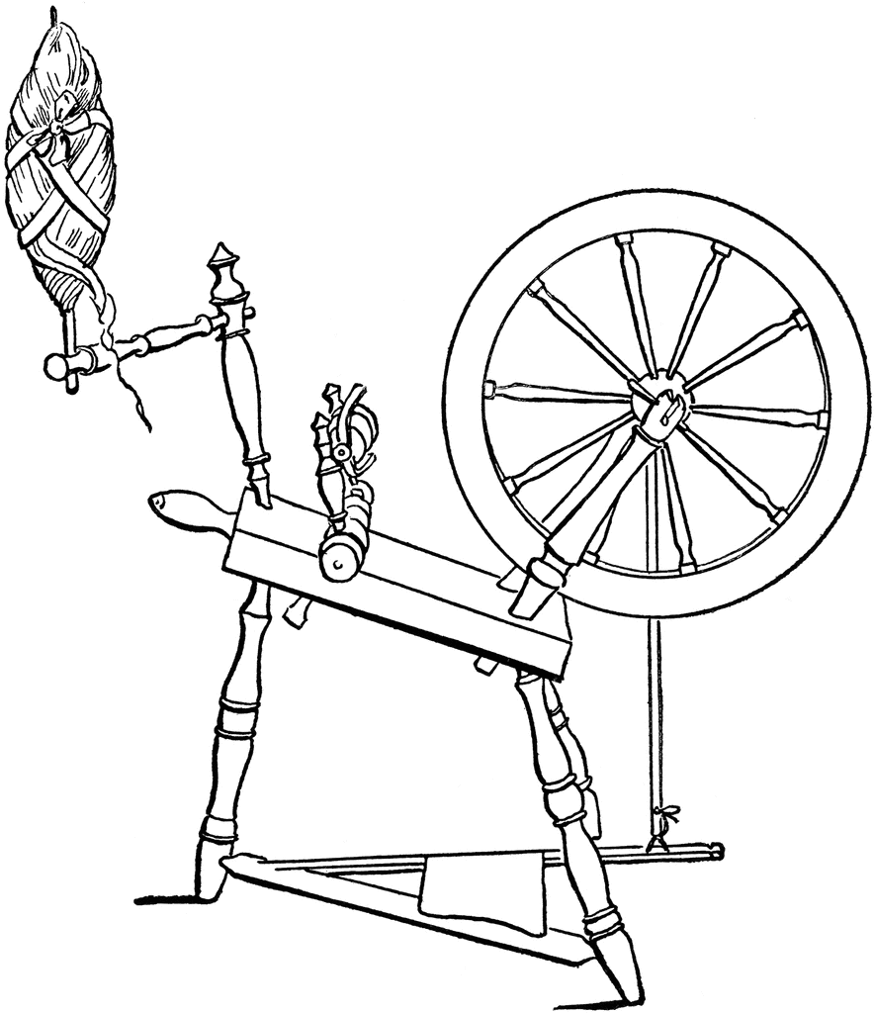

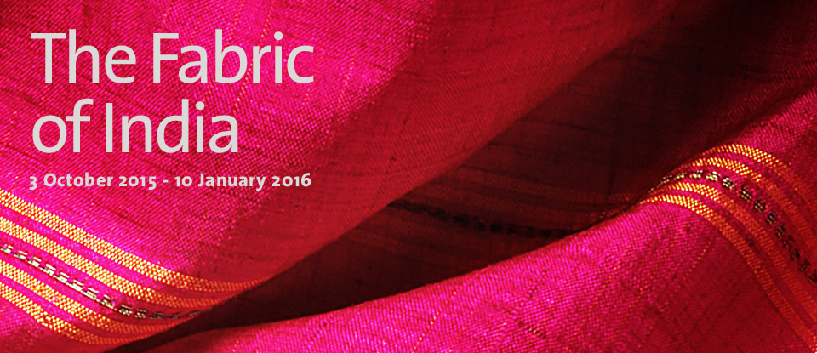
03 October 2015 – 10 January 2016. The highlight of the V&A’s India Festival, this will be the first major exhibition to explore the dynamic and multifaceted world of handmade textiles from India from the 3rd to the 21st century.

‘Can You Knit?’ by Hilary Hedderick

It was sometime in March 2000 that Sara and I were down at the farm shop where Carolyn Green worked. We had our usual chat about horses etc. Then Carolyn asked me if I could knit. Being a wary kind of person, I said ‘Sort of.’ She asked me if I would like to join her and a couple of other Spinners at the Audley End Easter Show where they had been asked to do a ‘Fleece to Garment in 14 hours.’ She suggested that I wore old clothes and brought talcum powder with the knitting needles as the fleece was still in the grease! (can’t do that now!)

On Saturday 1 April 2000, Carolyn took me to Audley End where she introduced me to Pamela Smith, Carole Thorpe and Hazel Mead who were the other members of the team. To begin with I sat and watched as they picked some fibres from the Jacob fleece that Carolyn had shorn a couple of days earlier and started spinning. It all looked very easy as they spun a thread. Soon they had enough on the bobbins to ply them together and then the fun started.

I was given this amazing thread to knit with. All fresh and greasy and the needles kept getting stuck and needing more talc on them. I persevered and soon there was a centimetre or two on the needle. I got quite excited. By about 4 o’clock they had spun a considerable amount and Carolyn started to knit another piece of the garment. We left about 5pm and were not allowed to do any more until the next day.

Sunday dawned and I kidnapped my daughter, Sara, to help with the knitting as Carole was unable to come that day. We all had a piece to knit by now; back, front, and two sleeves. We finished the jumper (28ins chest) at 3.45pm well within the time allowed. As you can see, we were all thrilled. Afterwards, the jumper was washed and sent off to a charity in Romania.

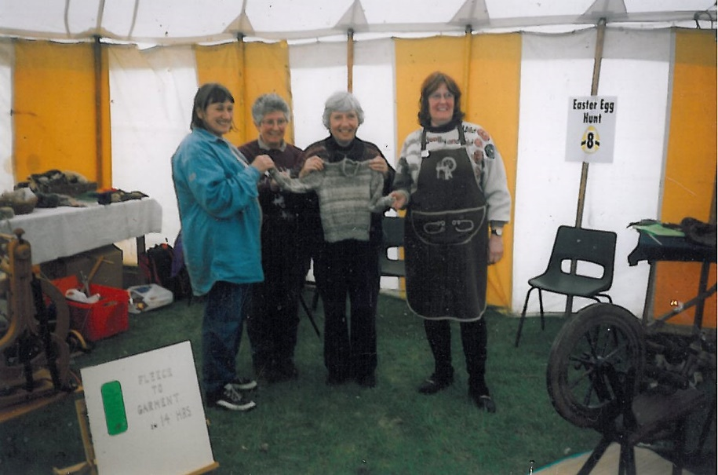

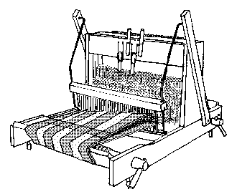
How I started Spinning
I grew up in a ‘home made’ household: my mother made our clothes, both knitted and sewn, while my father did the DIY, which included making all the built in furniture from scratch. I could make my own clothes before I was ten and I learned to wield a saw soon after that.
So, it was no surprise that I was interested in how things were made.

In 1970, I became involved in the annual ‘Feast and Fayre’ at Matching Tye. I was looking forward to seeing the man who made corn dollies but he died the week before. I was stung into action. It was a dying craft. A visit to the Corn Dolly Museum in Great Bardfield produced results. Mr Alfred Ruffles, would be running classes after the harvest.

For six weeks, I spent Monday evenings from 7.30 to 10.30 learning different techniques in straw plaiting. After an hour’s drive home, I then had to finish the current project while it was still damp, before going to bed.

I had bought some straw to continue making things but that soon ran out. When I tried to buy more, I discovered that the farmer had fallen ill and a contact farmer had cut all his straw including his dolly straw.

I then spent several weeks going to craft fairs looking for corn dolly makers who might give me the name of a supplier. Success at last in Romford, of all places. They would not give me the name of their supplier as they used all of his straw. However, they knew of a Mrs Goodwin near Kelvedon.
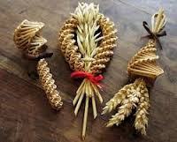

The Local Library came up trumps. None of this paying for credits to use the 192 website as the Library had all the telephone directories. I found Goodwin at Ashman’s Farm, Kelvedon, which seemed promising. A phone call established that I was right and I was soon supplied with good quality straw.

Jill Goodwin was a bit of a missionary with traditional crafts. She was desperate to keep the old skills going and saw me as a candidate for doing so. She was always interested in projects I was doing at school and showed me some of hers. Her current one was to spin a whole Jacob fleece for the local doctor who had bought Jill a washing machine, when she learned that Jill was still washing clothes by hand; a tall order when you have seven children.

She often used to tell me that she could get me a fleece, whenever I wanted one. One day, on the spur of the moment, I said, “Yes please” and she was off in her mini, leaving me drinking tea with Lewis, her husband. She returned with an enormous and very dirty fleece. It had not been skirted. At that time, I lived in a tower block. The whole fleece went straight in the bath, took ages to clean and the bathroom stank.

I put the wet fleece into an old pillow case and used a spin dryer to get most of the water out. It was then spread round the flat for days until it was dry.

Most schools in those days had weaving equipment lurking in cupboards but I was lucky enough to find a Dryad spindle, which I still use as it is so well balanced. I tried to spin but only succeeded in producing a very thick thread. I played around with some natural dyes and was pleased with the colours I achieved. As a yard of thread would only knit a few stitches, I decided to cut the yarn into short pieces and hook it into canvas to make a rug. Although a little faded after forty years, it is still a pleasure to walk on in bare feet.

I realised that I needed to learn to spin finer and faster so I visited Nancy at the Handweaver’s Studio in Walthamstow and ordered a wheel. When it arrived, just before Christmas, the box looked far too small to contain a whole wheel. Having followed the instructions, I tried to spin.
It was hopeless. A phone call to Jill sorted that problem.

In one evening, after school, the wheel was set up and I learned to spin lovely uneven, textured yarn. We were so involved in the spinning, that we forgot the time. An urgent warning from Lewis soon put paid to the spinning. It was snowing. My twenty-five mile journey home took me well over three hours and I didn’t get home until 12.30!

By Lesley Ottewell

The Silk Weavers of Spitalfields

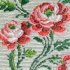

Guided walk

Tue 6th October 2015
2pm

Meet: Outside Christ Church Spitalfields
Commercial Street, London, E1 6LY
Many of the Huguenots (French Protestants) who left France after the Revocation of the Edict of Nantes in 1685 were weavers - over the years 25,000 settled in Spitalfields. They brought their skills (known as “the
Mysteries of the Strangers”), new techniques, new ideas and the incomparable French style. The master weavers lived in large, elegant houses whilst the journeymen weavers lived in small houses north of Spitalfields and Bethnal Green. You will hear about the silk industry, famous pattern designers, fashions, the weaving process and much more. Notably we will pass Anna Maria Garthwaite’s house and then hear the compelling story of this remarkable woman who died over 250 years ago.

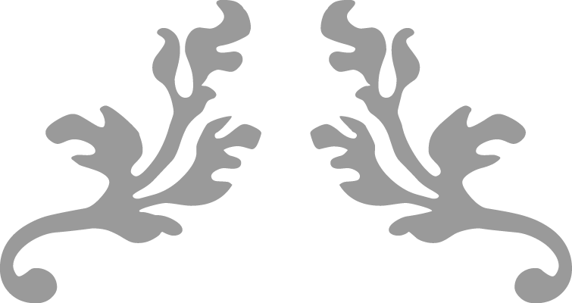

Thoughts on being a Committee Member...

Being a committee member isn’t an onerous task. Of course it involves a certain amount of thought and work but the rewards far outweigh the time volunteered, and it certainly seems the more you put in the more you get out. Participation in all aspects that the guild has to offer leads to a greater sense of inclusion and a greater confidence in one’s ability to try new skills. But there are still few contenders putting their names forward to join the committee. This is understandable. These days people lead very busy lives juggling a wealth of commitments and possibly many people feel being on the committee is someone else’s job. They just want to learn as much as possible working with fibre and enjoying their hobby. However, being a committee member doesn’t remove you from the process of pursing your craft but much more it enables a greater involvement in what seems to be an ever-expanding and exciting new horizon.

Incidentally, a synonym for ‘Musing’ is ‘Wool-gathering’!”

… and finally,
The Guild celebrated 35 years of spinning, weaving and dyeing at our July meeting. A good time was had by all with a variety or knitting, spinning, crochet, tapestry weaving, rag-rugging, Procion and indigo dyeing.
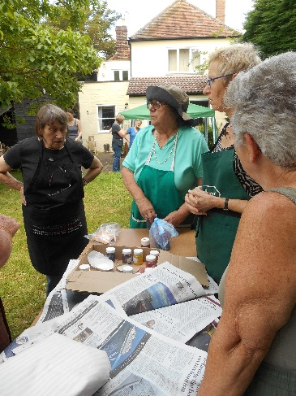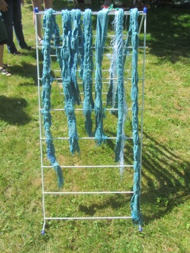
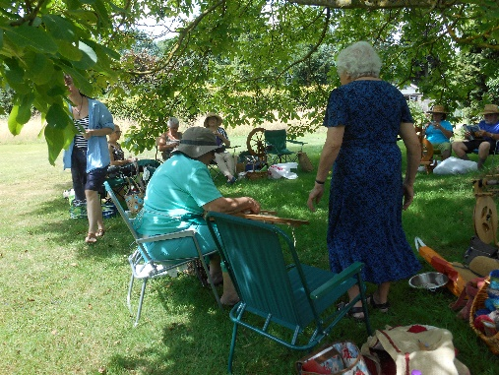
If you would like to contribute to the next edition of Threads or would like to add some information to our website, please contact Asela Ali at palmsnpeacocks@gmail.com
***
Lead Workshops will need to be booked through our Treasurer and paid for in advance.
***
If you would like to propose a speaker or workshop or would like us to come and demonstrate, please contact our Programme Secretary.
***
To borrow equipment or books from the Guild library please contact a member of the committee.
***
THREADS

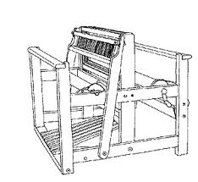

Monthly meetings at Harlow Museum
Muskham Road
CM20 2LF

